
QUALITY ALERT

Customer: Solar Date: October 16, 2024
Die: 15001 Type of Complaint: Solar REJECTED

Description: Solar REJECTED due to off square on and off, when welded together, pieces are not aligned.
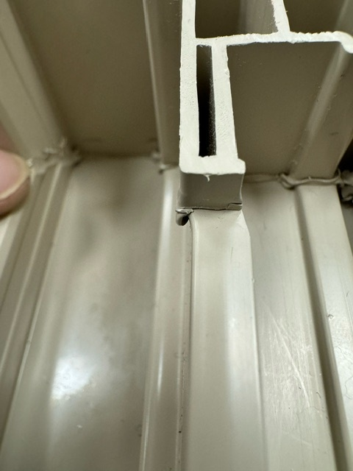
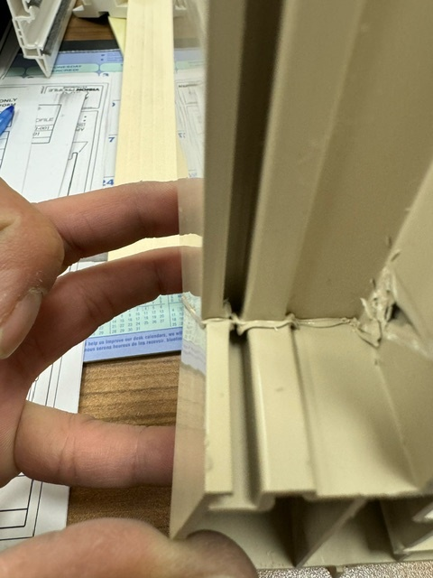

PLEASE MAKE SURE TO CHECK THE PIECES CAREFULLY

BY SIGNING BELOW, YOU ACKNOWLEDGE THE PROBLEM ABOVE AND AGREE TO MONITOR THIS ISSUE IN FUTURE PRODUCTION RUNS.
DAY SHIFT |  | AFTERNOON SHIFT |  | NIGHT SHIFT
NAME | SIGNATURE | NAME | SIGNATURE | NAME | SIGNATURE

